ARTIFICIAL INTELLIGENCE – CO1 AT-2

Q1. Apply Backtracking Search to Assign Three Doctors to Three Shifts. Show All Intermediate Steps, Constraint Checks, and the Final Valid Schedule.

1. Problem definition
Backtracking search is a problem-solving technique that builds a solution step by step. Whenever a partial solution violates a constraint, the algorithm rejects that assignment and tries another possibility.
Three doctors, D1, D2, and D3, must be assigned to three shifts:
- Morning (M)
- Afternoon (A)
- Night (N)
The objective is to assign exactly one shift to each doctor while satisfying all the given constraints.

2. Given constraints
- D1 cannot work the night shift.
- D2 must work before D3.
- Only one doctor can work in each shift.
- D3 cannot work the morning shift.
- Each doctor must receive exactly one shift.

3. Step-by-step backtracking procedure
Step 1: Assign D1.
D1 can work either Morning or Afternoon, but not Night.
Try D1 = Morning.
Step 2: Assign D2.
D2 must work before D3. Therefore, D2 cannot be assigned a shift later than D3.
Try D2 = Afternoon.
Step 3: Assign D3.
The remaining shift is Night. D3 is not allowed to work Morning, so Night is permitted.
Thus, D3 = Night.

4. Constraint checking table
Constraint | Assignment checked | Result
D1 cannot work Night | D1 = Morning | Satisfied
D2 works before D3 | Afternoon < Night | Satisfied
One doctor per shift | M, A, N assigned once each | Satisfied
D3 cannot work Morning | D3 = Night | Satisfied
Every doctor has one shift | D1, D2, D3 assigned once | Satisfied

5. Backtracking tree
Start: Assign D1
D1 = Morning
D2 = Afternoon
D3 = Night — All constraints satisfied

6. Final valid schedule
Shift | Doctor
Morning | D1
Afternoon | D2
Night | D3

7. Conclusion
Backtracking search successfully finds the valid schedule by assigning shifts one at a time and checking each constraint. The final assignment satisfies all five conditions without conflicts. Under the given interpretation that D2 must work earlier than D3, this is the only valid schedule.

Q2. A Robot Must Move from Start to Goal in a 5 × 5 Grid. Explain the Search Algorithm, Show Node Expansion and Queue Updates, and Determine the Optimal Path and Cost.

1. Introduction
Breadth-First Search (BFS) is an uninformed search algorithm that explores nodes level by level. It first visits all nodes at depth 1, then depth 2, and continues until the goal is reached.
When every movement has a cost of 1, BFS guarantees a shortest path in terms of the number of moves.

2. Given conditions
- Grid size: 5×55\times55×5
- Start position: S
- Goal position: G
- Allowed movements: Up, Down, Left, Right
- Cost per movement: 1
- Obstacles cannot be crossed.
- Manhattan distance is the given heuristic.
The Manhattan distance between a current cell (x,y)(x,y)(x,y) and goal cell (xg,yg)(x_g,y_g)(xg,yg) is:
h(n)=∣x−xg∣+∣y−yg∣h(n)=|x-x_g|+|y-y_g|h(n)=∣x−xg∣+∣y−yg∣
Here, h(n)h(n)h(n) estimates the number of horizontal and vertical moves required to reach the goal.
Note: BFS uses a FIFO queue and does not use a heuristic to prioritize nodes. The Manhattan heuristic is used in informed algorithms such as A*. Since the question asks for BFS, the following example demonstrates BFS and calculates the heuristic separately.

3. Illustrative grid
Because the question paper does not provide obstacle coordinates, assume for demonstration that S is at (1,1), G is at (5,5), and obstacles occupy (2,2), (2,3), and (4,4).
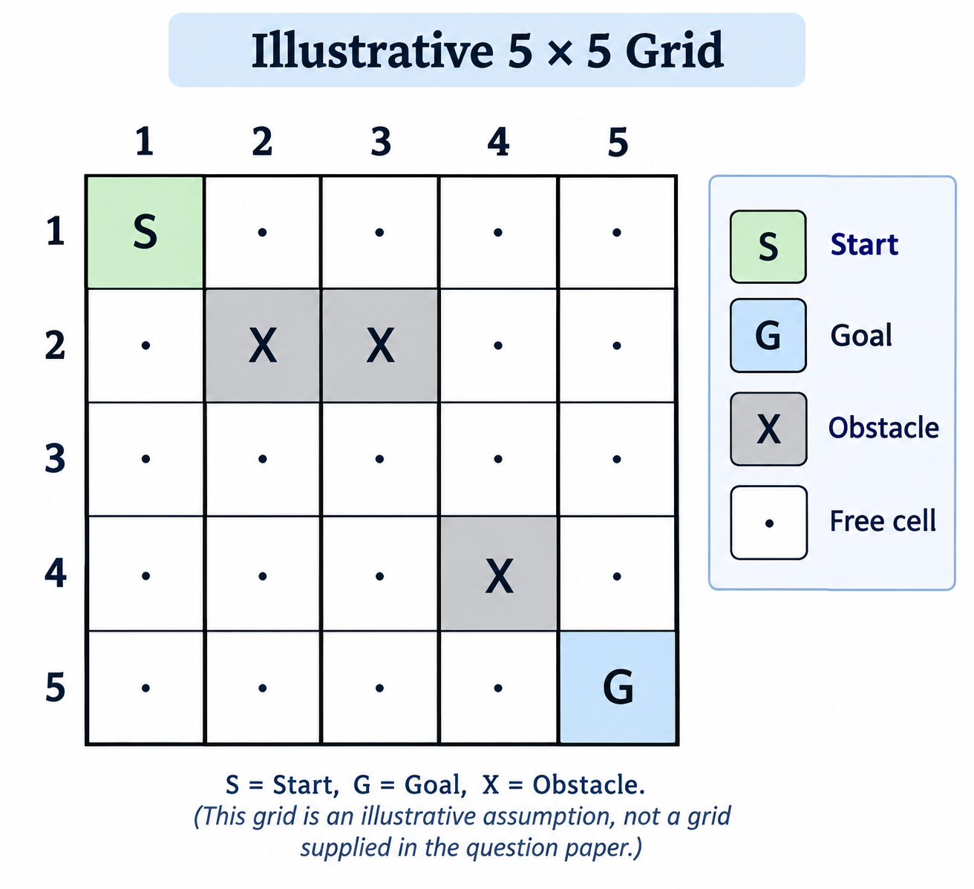
S = Start, G = Goal, X = Obstacle. This grid is an illustrative assumption, not a grid supplied in the question paper.

4. Step-by-step BFS node expansion
BFS maintains a queue of nodes waiting to be explored. Visited cells are not added again, and obstacle cells are rejected.
Step | Node expanded | Action / queue update
1 | S (1,1) | Add (2,1), (1,2)
2 | (2,1) | Add (3,1); reject blocked (2,2)
3 | (1,2) | Add (1,3); reject blocked (2,2)
4 | (3,1) | Add (4,1), (3,2)
5 | (1,3) | Add (1,4); reject blocked (2,3)
6 | (4,1) | Add (5,1), (4,2)
7 | (3,2) | Add (3,3)
8 | (1,4) | Add (1,5), (2,4)
9 | (5,1) | Add (5,2)
10 | Further nodes | Continue level by level until G is reached
The precise expansion order depends on the order in which neighboring cells are examined. The table illustrates the early expansions under the assumed grid.

5. Queue updates and optimal path
At the beginning:
Q=(1,1)(1,1)Q=(1,1)(1,1)Q=(1,1)(1,1)
After expanding S:
Q=(2,1),(1,2)(2,1),(1,2)Q=(2,1),(1,2)(2,1),(1,2)Q=(2,1),(1,2)(2,1),(1,2)
After expanding (2,1):
Q=(1,2),(3,1)(1,2),(3,1)Q=(1,2),(3,1)(1,2),(3,1)Q=(1,2),(3,1)(1,2),(3,1)
The queue follows the First-In, First-Out principle. BFS explores all reachable cells at a given depth before moving to the next depth.
One optimal path for the illustrative grid is:
(1,1)→(2,1)→(3,1)→(4,1)→(5,1)→(5,2)→(5,3)→(5,4)→(5,5)\begin{aligned} (1,1)&\rightarrow(2,1)\rightarrow(3,1)\\ &\rightarrow(4,1)\rightarrow(5,1)\\ &\rightarrow(5,2)\rightarrow(5,3)\\ &\rightarrow(5,4)\rightarrow(5,5) \end{aligned}(1,1)→(2,1)→(3,1)→(4,1)→(5,1)→(5,2)→(5,3)→(5,4)→(5,5)
This path avoids all three assumed obstacles.

6. Calculation of path cost
Each movement costs 1.
The path contains four downward moves and four rightward moves.
Total cost=4(1)+4(1)=8\text{Total cost}=4(1)+4(1)=8Total cost=4(1)+4(1)=8
The Manhattan distance from S to G is:
h(S)=∣5−1∣+∣5−1∣=8h(S)=|5-1|+|5-1|=8h(S)=∣5−1∣+∣5−1∣=8
Since eight moves are necessary even without obstacles, the demonstrated path has the minimum possible cost.

7. Conclusion
BFS finds an optimal path in a grid with equal movement costs by exploring nodes level by level. The illustrative optimal path has a cost of 8. However, the exact official node expansion sequence and path require the actual obstacle positions from the question paper.

Q3. An Autonomous Rescue Robot Must Locate a Survivor in a Partially Observable Environment. Analyze the Constraints, Develop a Search Strategy, Apply AI Concepts, and Justify the Approach.

(a) Analyze the constraints and explain their effect on decision-making.
An autonomous rescue robot uses artificial intelligence to navigate a disaster-affected building and reach a survivor safely. The building is represented as a grid in which some cells are blocked or risky. Since the robot cannot observe the entire environment, it must make decisions using limited information and update its knowledge as it moves.
The given constraints affect the robot in the following ways.
Constraint | Effect on decision-making
Movement in four directions | The robot considers only Up, Down, Left, and Right.
Blocked cells | The robot must avoid obstacles and search for alternative routes.
Limited sensing | It observes only adjacent cells and cannot know the entire map initially.
Movement cost = 1 | Each normal move contributes one unit to the total cost.
Risk-zone cost = 2 extra | Entering a risky cell costs 3 in total: 1 for movement and 2 additional units.
Dynamic knowledge | The robot updates its internal map whenever new information is obtained.
Safety requirement | It must avoid known hazards and choose a safe, low-cost route to the survivor.
Therefore, the robot must balance movement efficiency, risk avoidance, and incomplete information rather than simply choosing the shortest geometric path.

(b) Develop a solution using an appropriate search strategy.
Chosen strategy: Online Search Agent with Uniform Cost Search (UCS) principles.
Uniform Cost Search expands the frontier node with the lowest accumulated path cost. It is suitable for this problem because entering a risky zone increases the cost of a route.
The robot also needs an online-search mechanism because it discovers obstacles and safe passages while moving.
Step-by-step procedure
- Initialize: Place the robot at S and create an initial map containing only the information currently available.
- Sense the surroundings: Observe the four adjacent cells and identify whether they are free, blocked, or risky.
- Update the map: Record newly discovered obstacles, risk zones, and accessible cells.
- Calculate movement costs: Assign a cost of 1 to a normal move and a cost of 3 to a move into a risky zone.
- Select the next node: Choose the lowest-cost reachable option using the known information.
- Move safely: Execute one movement and observe the new surroundings.
- Repeat the search: Update the map and reconsider the route whenever new information changes the available choices.
- Reach the goal: Continue until the survivor's location G is reached.
The path cost can be represented as:
g(n)=∑i=1ncig(n)=\sum_{i=1}^{n}c_ig(n)=i=1∑nci
where:
- g(n)g(n)g(n) = total cost from the start to the current node.
- ci=1c_i=1ci=1 for a normal movement.
- ci=3c_i=3ci=3 when entering a risky cell.
Pseudocode
Initialize start position S
Initialize known map and cost frontier

While goal G is not reached:
Observe adjacent cells
Update map with new information
Identify safe and reachable cells
Calculate movement costs
Select the lowest-cost available route
Move to the selected cell
Update total path cost

Return the route and total cost
UCS finds a minimum-cost path when the relevant map is known and all step costs are non-negative. In an initially unknown environment, the online agent must repeatedly replan as it discovers new information; it cannot guarantee a globally optimal route from incomplete knowledge alone.

(c) Demonstrate the application of AI concepts.
1. Intelligent agents
An intelligent agent perceives its environment through sensors and acts on it to achieve a goal.
In this scenario, the rescue robot senses adjacent cells, updates its map, chooses a movement, and repeats the process until it reaches the survivor.
The basic agent cycle is:
Perceive the surroundings
Update the internal map
Evaluate cost and safety
Choose and execute an action
Observe again and replan
2. Rationality
A rational agent selects actions that best achieve its objective using the information currently available.
The rescue robot should choose a route that minimizes total movement cost while avoiding known obstacles and unnecessary exposure to risky zones. It should also reconsider its decision when new information becomes available.
3. Environment type
Environment property | Classification | Reason
Observability | Partially observable | Only adjacent cells can be sensed.
Determinism | Partially specified | The question does not define whether actions have uncertain outcomes.
Dynamics | Dynamic or changing knowledge | New information becomes available during movement.
State space | Discrete | The building is represented as grid cells.
Agents | Single-agent | Only the rescue robot is specified as making decisions.
Planning | Sequential | Each movement affects subsequent decisions and total cost.
The environment is clearly partially observable, discrete, and sequential. Its physical dynamics are not fully specified, so they should not be assumed to be stochastic or changing independently of the robot without further information.

(d) Justify why the chosen approach is suitable.
The online-search and UCS-based approach is suitable for the following reasons:
- Handles incomplete information: The robot can begin navigating without knowing the complete map.
- Supports dynamic updates: It can revise its route when it discovers an obstacle or a risky zone.
- Considers different costs: UCS accounts for the extra cost of entering risky cells rather than treating every route as equally expensive.
- Improves safety: The robot can avoid known blocked cells and prefer safer alternatives when appropriate.
- Supports sequential decisions: The robot can repeatedly observe, plan, move, and replan.
- Provides cost-based reasoning: With a known map and non-negative movement costs, UCS finds a minimum-cost route.
A limitation is that the robot cannot guarantee the globally safest or cheapest route before discovering the unknown environment. Its decisions depend on the quality of its sensors, the accuracy of its map, and the information available at each stage.

Conclusion
The autonomous rescue robot demonstrates intelligent-agent behaviour by sensing, reasoning, planning, and acting in a partially observable environment. An online-search agent combined with Uniform Cost Search principles is appropriate because it can update its knowledge and consider different movement costs. This approach helps the robot navigate obstacles, reduce unnecessary risk, and reach the survivor efficiently.

